Title or Task: | AIT2a Task : 1  
Description: | Guide To Concepts in AIT

Files Required
Suitable for Classes: | Applied Information Technology
Area: | Technology & Enterprise
Teacher: | Mr Peter Faulks
Marks: | Worth: | Weighting:

Date Due:

Task Brief:
Outcomes: | Investigation Plan Produce Review Test

Items highlighted in yellow are tasks for you to complete
Items in Blue are help tips

Open Power Point
Create a template using colour and consistent fonts throughout, duplicate the first slide and create the following slides: (Samples from student work is shown)
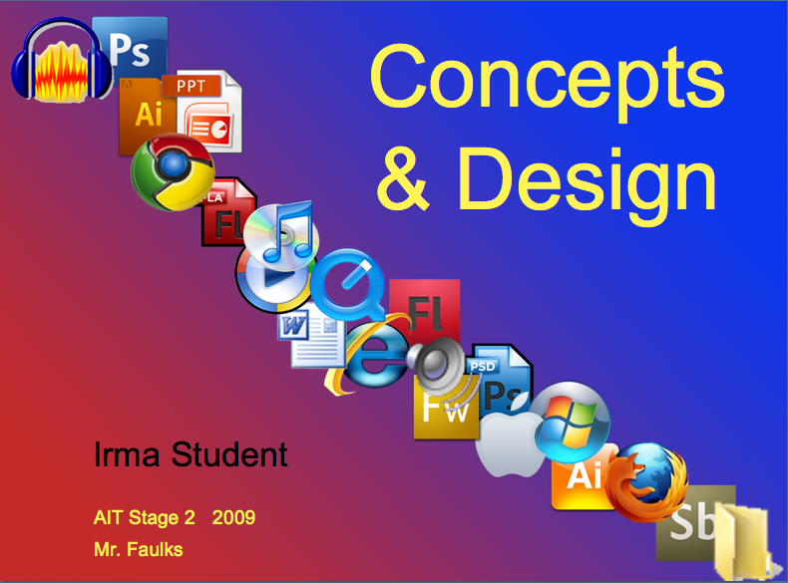
- Materials
- File Formats
- Compression
- Navigation
- Technology Process
- SPARC Principles
- Impact of colour
- Metaphors
- Navigation Design
- Post Production
- My Screen Template
- Help Page – also THE END page

  - Create a hyperlink from each content title to the appropriate page
  - Create buttons linking all the pages
  - Include a help page explaining how to navigate about the presentation
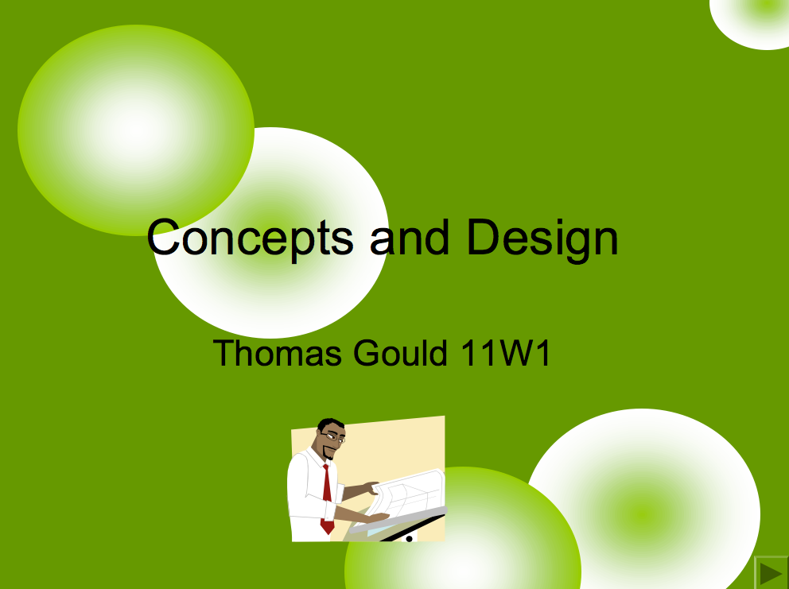
Save the file as:

Portfolio 1 Concepts & design.ppt

Add to your Task 6 portfolio folder

On the First Slide Cover page

Create an image that conveys the title, your name, class name and year

Slide 1 Main Menu
This portfolio is to keep SET OF SAMPLES OF ALL MY DIGITAL Media skills. The key design features will be: consistent background, consistent title, consistent layout, metaphors to assist understanding, navigation that works properly and accurate content.
My audience will be 14 year olds to adults, particularly my teacher.
My presentations are hyper linked through a set of menus and sub menus. The navigation is hierarchical.

Key design features are a user-friendly hierarchal/webbed navigational system and many hyperlinks, which will link to displays of digital media work. The carrier software for this presentation will be PowerPoint. There are many examples in this presentation, which is only a ‘click!’ away, including plenty of explanations and definitions. There are some interesting examples of creative media work, providing viewers with a variety of aspects involved in Digital Media.

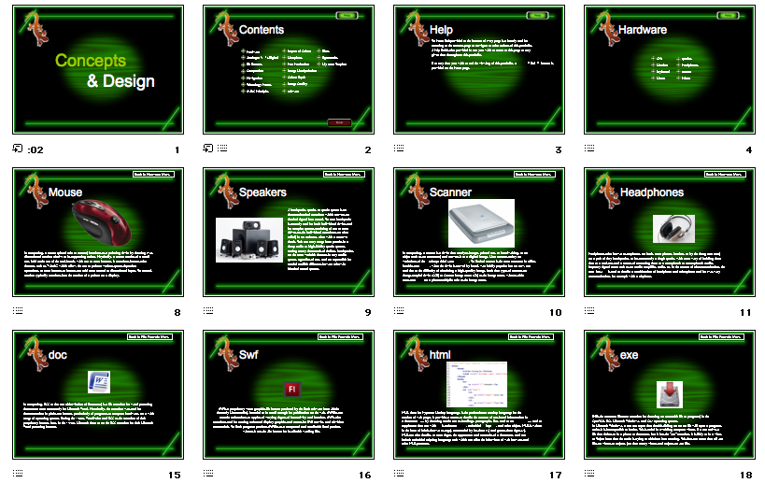
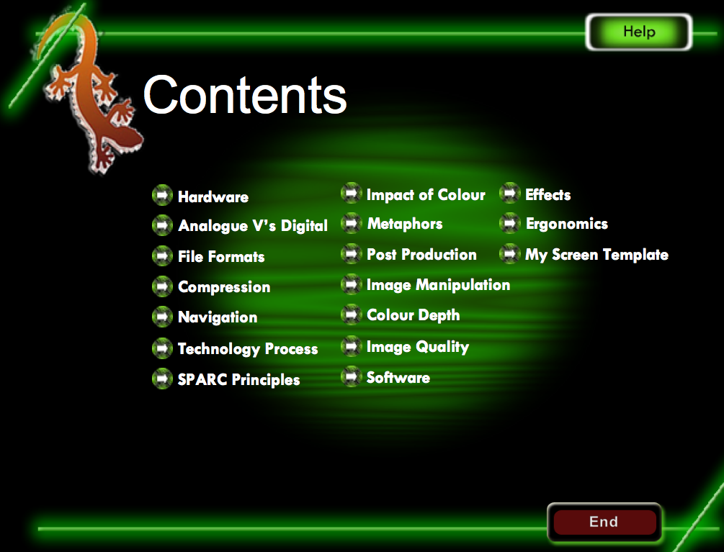

Slide 2 Materials (include picture)
Hardware – the physical components of the computer.
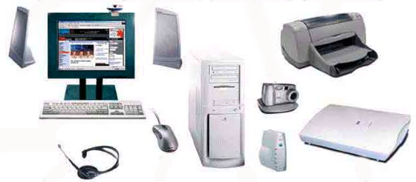
Software – The applications that make the computer do things.

Peripherals – All the extra things you connect to a computer (eg. Webcam, printer, scanner, keyboard, headphones)

Network – The cabling or wireless signals that connect computers together.

Infrastructure – the entire system all linked together (hardware, software, network connections, server).
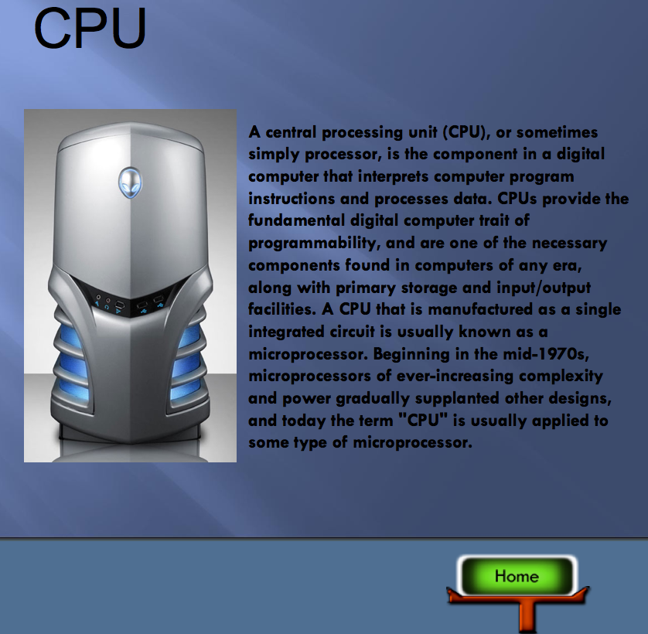

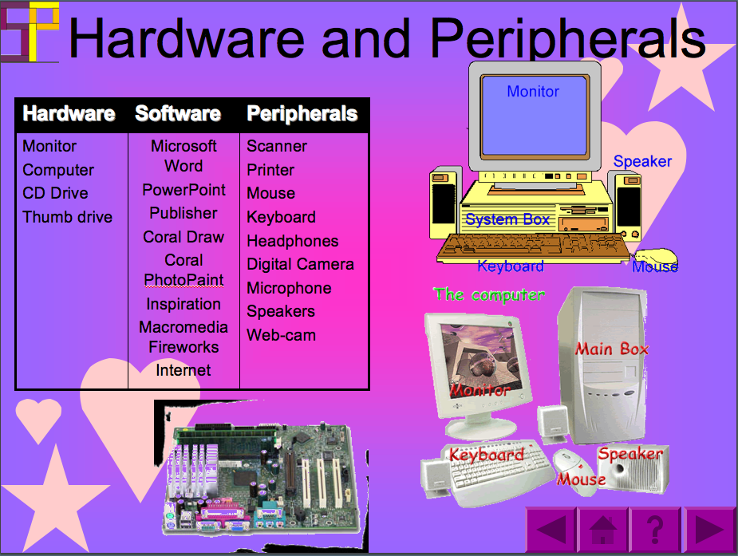
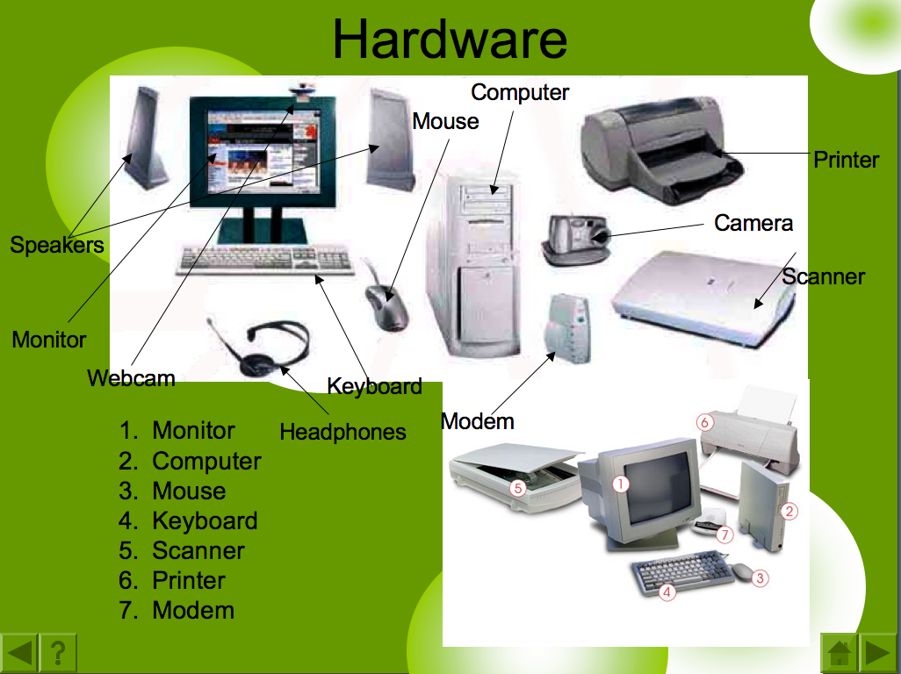
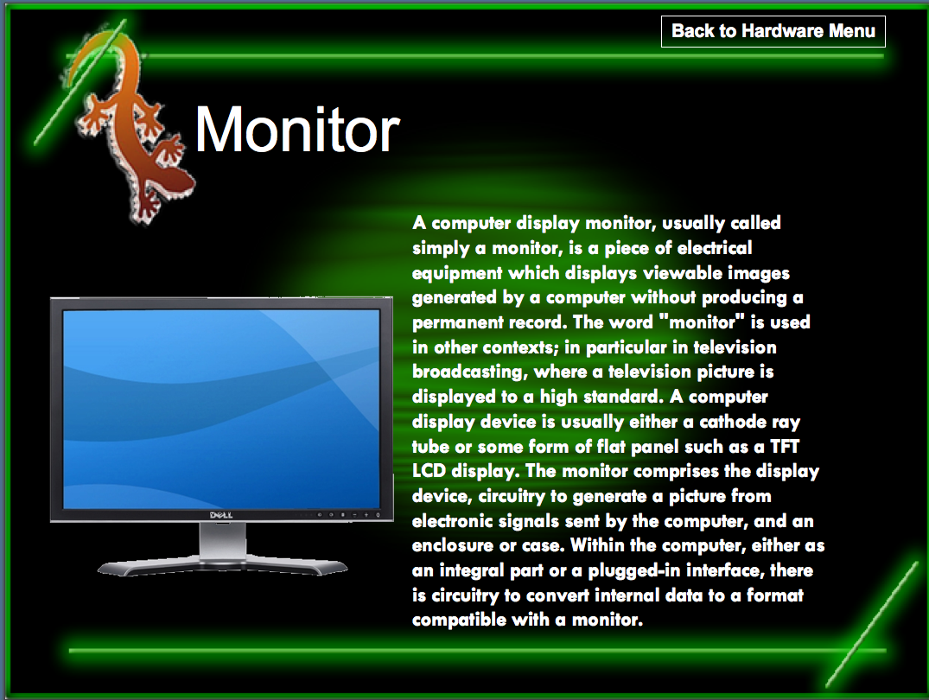
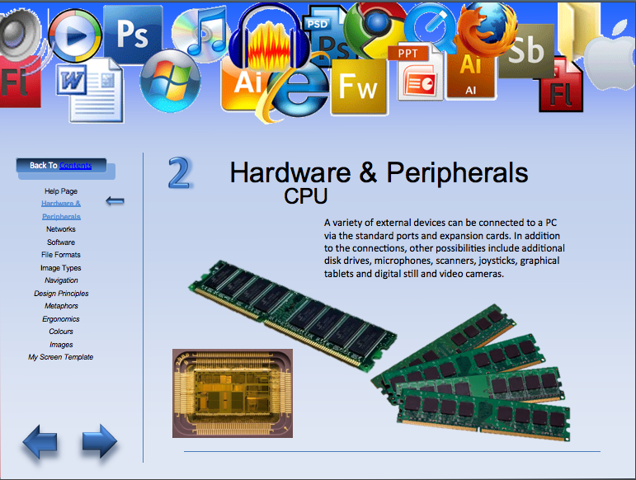

Slide 3 File Formats

Open the File Format .doc

Table of file formats and use at least four (4) samples

Type | Name | Description | Compression
Audio | .aiff |  | Y/N
Video | .mpg
Text | .doc | 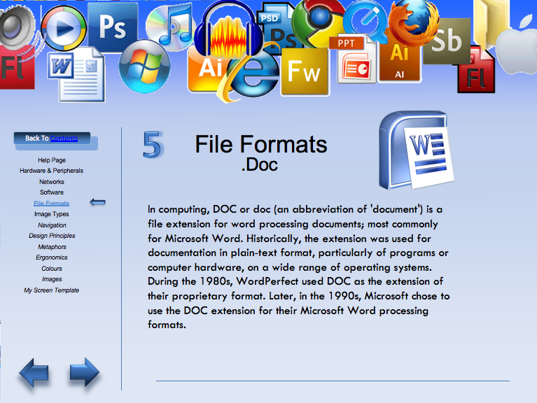
Image | .jpg
Other

Compression means reducing file size. Lossy etc.

Gather more information –
show samples of two files compressed vs uncompressed

We would export multimedia files into different formats so that other programs will understand and accept them, or to make them smaller. For example, PowerPoint does not accept Audacity files but if we export them to .wav it will. Sometimes files are too big, like Corel photo paint, so we export them to .jpg, which are smaller. An. aiff file is very high quality. If we export it to .wav, it will be much smaller but the sound quality is not so good. You sacrifice quality for the smaller size.

Slide 4 Navigation

Linear – means you navigate in a straight line

Hierarchical – means you go through a menu system.

Webbed navigation - mixture

Slide 5 Technology Process – inspiration Chart

Slide 6 SPARC Principles
Symmetry: Arranging different elements evenly on the page.
Simplicity: Keeping elements simple and uncluttered.
Syntax: The cues that may help the reader follow the order of paragraphs.
Eg. Bullets and numbers.

Place: Where things are put.
Proximity: Related items placed together. (Positioning objects should balance Focus appropriately. Eg. Photo on the left, and text on the right).

Accuracy: The text needs to be accurate.
Alignment: Refers to the lining up of the elements on a page. (keep objects accurately in line to make easy viewing)
Accuracy: Spelling and facts must be accurate
Readability: Text needs to be seen and read easily and quickly. (Continue with a main theme throughout presentations).

Relevance: The text needs to be relevant.
Repetition:
Re-usability:

Consistency: The way in which elements are used to give the work a certain style and to achieve unity.
Clarity: Consistency is attained through repetition and it aids clarity, because the visual clues are predictable.
Colour: Contrast colours to make it easy to view.

Colour:
Contrast: Contrast colours to make it easy to view.

Slide 7 Impact of Colour
Colour is a significant aspect of all visual presentations, as it is a means of non-verbal communication with audiences. Colours can reflect moods, feelings and connote certain ideas (eg. Red connotes danger and hazard). Certain colours are suitable for particular situations (eg. Black and grey symbolise formality and intelligence, and are a good combination for business reports, however, hot pink and lime green would be unsuitable.)

Colours can have an effect on people’s moods and emotions. Advertising agencies may use the colour red to symbolise aggression and power when promoting a sporting brand, as it conveys subconscious ideas that wearing and using this brand will help consumers to be faster, stronger and intense when playing sport.

Colours have been chosen throughout this presentation strategically also. The colour blue has been used in the background to convey a calm, stable; orderly and technological feel about the presentation, with black writing to convey formality and power. Grey has been used for icons and metaphors as it represents practicality and reliability.

Colour can be an indicator of mood, it can also show company or team colours, and triggers a universal understanding of an emotion or mood.

Slide 8 Metaphors
Metaphors are commonly used in computer games, digital presentations and even in instruction manuals. Metaphors are used to express movements throughout presentations quickly and efficiently. They are used to be directive and are important as they provide a simple navigation system.

Televisions remotes, DVD players, Sony Play station and mobile phones all use their own forms of metaphors. All people can find metaphors easy to use even those who are computer illiterate.

A good metaphor let people use them without thinking.

Slide 9 Navigation design

1 Linear 2 Hierarchal 3 Web

Slide 10 Screen Templates
Templates are useful for preserving the look and feel of media

Slide 11 Help & THE END

This button will return you to the Main Menu
This button will take you to the next slide
This button will return you to the previous slide

Evaluation Individual Task

Task Number

Your Name Date

Consider the Task that you have recently completed, carefully and critically evaluate your work by answering the following questions.

1. What was the purpose of the task part a?
Answer:
What was the purpose of the task part b?
Answer:

2. Who was your intended audience of your tasks?
Answer:

3. How well do you think your design suits the intended audience?
□  Very well | □  Quite well | □  Not sure | □  Could be improved | □  Audience not considered in the design

4. Have you been able to test your design on someone from your intended audience group?
What was their reaction?
Answer:

5. How many samples were you able to view to help you investigate your topic for the power point?
□  None | □  1 or 2 | □  About 5 | □  Between  5 and 10 | □  More than 10

6. How did you decide which software to use for your background?
□  I produced several versions in different software and chose the best | □  I did some drafts in a couple of applications and chose the best one to complete it in | □  I began using one application and swapped to another when my skill levels increased | □  I only used one of the suggested applications | □  I only tried word processing software

7. How original was your design?
□  I copied a design I had seen elsewhere | □  I copied a design and changed the colouring and shapes | □  I used a variety of designs and combined different aspects of them | □  I used a variety of ideas as inspiration and then developed my design | □  Completely original

8. Did you produce and keep draft copies of your background and your written response?
□  Yes, my pencil and paper drafts are in my hardcopy portfolio and my digital copies are in my electronic portfolio | □  Yes but only a digital draft version | □  Yes but I only kept a hardcopy draft | □  Yes I did but I didn’t keep any copies | □  No, only a final copy

9. Are you happy with your image manipulation skills at this stage?
□ Yes □ No
Explain
Answer:

10. Would you like to develop your skills in image manipulation further since completing this task?
□ Yes □ No

11. Did you find any restrictions to your ability to manipulate your images?
Answer:

12. Did you check your task for spelling and grammar mistakes?
□ Yes □ No

Why / Why not?
Answer:

13. How did you feel about your time management for Task 1?
□  I need a lot more time to finish my event item properly | □  I spent more time than suggested in preparing my event item | □  It took me about the same time suggested in the course to complete my event item | □  I was able to work quite quickly and had some time to spare | □  I worked very quickly and was able to spend time refining my item through learning more application tools
14. Have another look at the Scenario and the Task 1 Explained. Do you believe this item meets the requirements of the task? Explain
Answer:

Save your evaluations as (your initials)_task_eval into your folder, attach it to the web link site or email it to me before the end of the week.


